Database Creation

create database amazon_survey;

use amazon_survey;

-- Total number of Surveys

select count(*) from customer_behavior_survey;

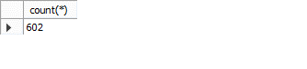

-- Purchase freequency based on gender, age

select Purchase_Frequency, count(Gender)

from customer_behavior_survey

where Gender = "Male"

group by Purchase_Frequency;

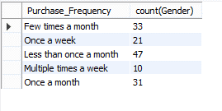

select Purchase_Frequency, count(Gender)

from customer_behavior_survey

where Gender = "Female"

group by Purchase_Frequency;

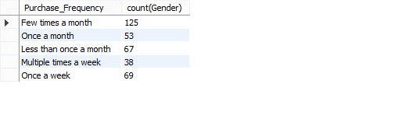

select Purchase_Frequency, count(Gender)

from customer_behavior_survey

where Gender = "others"

group by Purchase_Frequency;

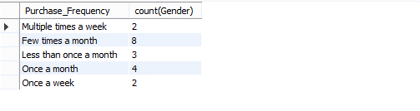

select Purchase_Frequency, count(Gender)

from customer_behavior_survey

where Gender = "Prefer Not to say"

group by Purchase_Frequency;

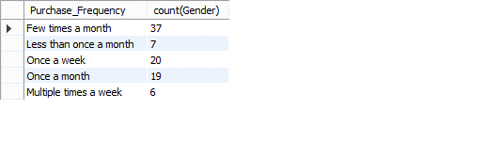

select Purchase_Frequency,

case

WHEN age BETWEEN 0 AND 15 THEN '0 - 15'

WHEN age BETWEEN 16 AND 30 THEN '16 - 30'

WHEN age BETWEEN 31 AND 45 THEN '31 - 45'

WHEN age BETWEEN 45 AND 60 THEN '45 - 60'

WHEN age > 60 THEN '60 +'

end as age_group, count(Purchase_Frequency)

from customer_behavior_survey

group by Purchase_Frequency, age_group

order by age_group;

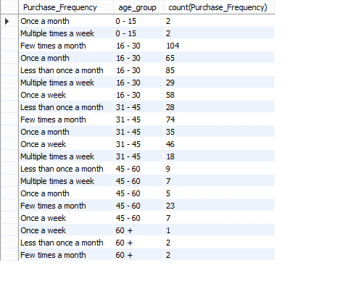

-- Product Puchase (Based on gender, age)

select Purchase_Categories, count(Gender)

from customer_behavior_survey

where Gender = "Male"

group by Purchase_Categories

order by count(Gender) desc;

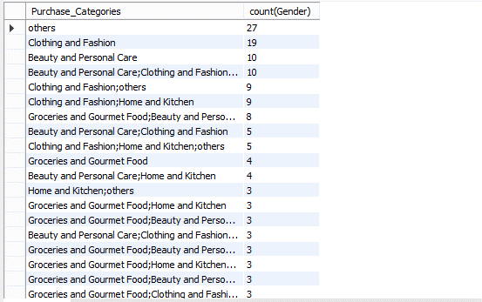

select Purchase_Categories, count(Gender)

from customer_behavior_survey

where Gender = "Female"

group by Purchase_Categories

order by count(Gender) desc;

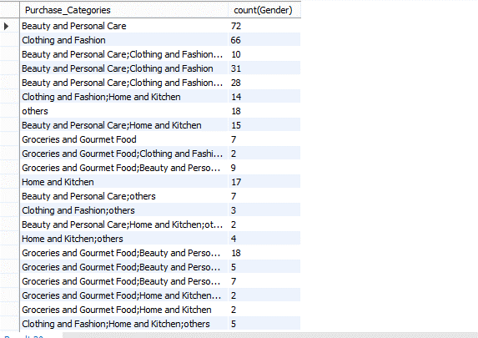

select Purchase_Categories, count(Gender)

from customer_behavior_survey

where Gender = "others"

group by Purchase_Categories

order by count(Gender) desc;

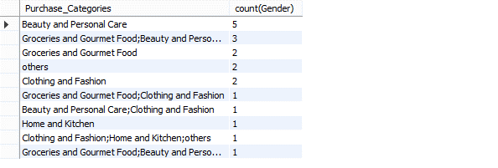

select Purchase_Categories, count(Gender)

from customer_behavior_survey

where Gender = "Prefer not to say"

group by Purchase_Categories

order by count(Gender) desc;

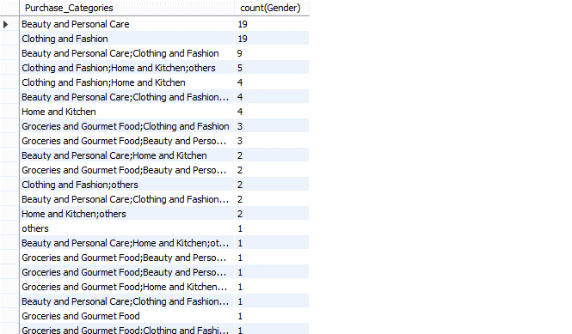

select Purchase_Categories,

case

WHEN age BETWEEN 0 AND 15 THEN '0 - 15'

WHEN age BETWEEN 16 AND 30 THEN '16 - 30'

WHEN age BETWEEN 31 AND 45 THEN '31 - 45'

WHEN age BETWEEN 45 AND 60 THEN '45 - 60'

WHEN age > 60 THEN '60 +'

end as age_group, count(Purchase_Categories)

from customer_behavior_survey

group by Purchase_categories, age_group

order by count(Purchase_Categories) desc;

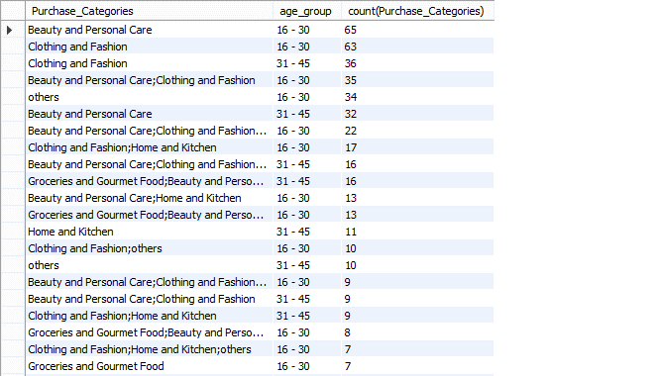

-- Browsing Frequency (Based on gender, age)

select Browsing_Frequency, count(Gender)

from customer_behavior_survey

where Gender = "Male"

group by Browsing_Frequency;

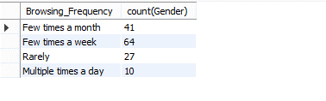

select Browsing_Frequency, count(Gender)

from customer_behavior_survey

where Gender = "Female"

group by Browsing_Frequency;

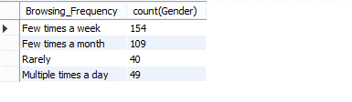

select Browsing_Frequency, count(Gender)

from customer_behavior_survey

where Gender = "others"

group by Browsing_Frequency;

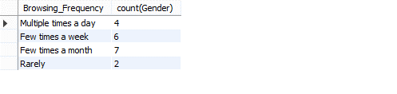

select Browsing_Frequency, count(Gender)

from customer_behavior_survey

where Gender = "Prefer Not to say"

group by Browsing_Frequency;

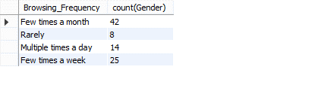

select Browsing_Frequency,

case

WHEN age BETWEEN 0 AND 15 THEN '0 - 15'

WHEN age BETWEEN 16 AND 30 THEN '16 - 30'

WHEN age BETWEEN 31 AND 45 THEN '31 - 45'

WHEN age BETWEEN 45 AND 60 THEN '45 - 60'

WHEN age > 60 THEN '60 +'

end as age_group, count(Browsing_Frequency)

from customer_behavior_survey

group by Browsing_Frequency, age_group

order by age_group;

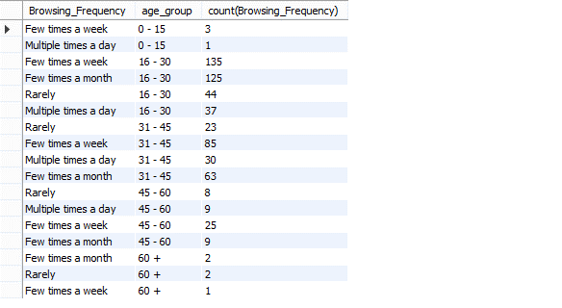

-- Resaons of service appreciation

select Service_Appreciation, count(Service_Appreciation)

from customer_behavior_survey

group by Service_Appreciation

order by count(Service_Appreciation) desc;

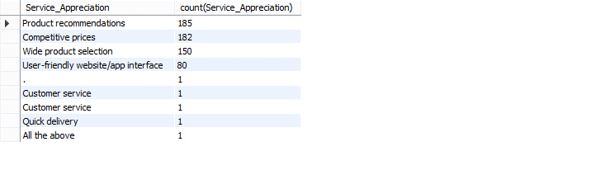

-- If reccomendations were helpful

select Recommendation_Helpfulness, count(Recommendation_Helpfulness)

from customer_behavior_survey

group by Recommendation_Helpfulness;

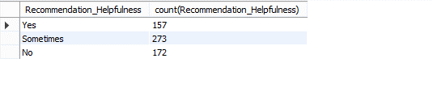

-- Recommmendation for improvement

select Improvement_Areas, count(Improvement_Areas)

from customer_behavior_survey

group by Improvement_Areas

order by count(Improvement_Areas) desc;

